Graduation Thesis

**Anti-tumor Drug Delivery via Targeted Yeast Vacuole System**

*Dec 11, 2014*

Kyungrin, Noh

20090322, Biological Sciences

**INTRODUCTION**

Targeted drug delivery is a popular research area, for it can concentrate drug’s effect on target area and avoid any side effects on other sites. Especially for drug treatments for cancer, the medication is highly toxic which can kill any normal cells. But traditional drug delivery system lets such drug to flow all over the body through blood circulation. This results severe side effects for patients. Targeted drug delivery method alleviates such problems by using active system to specifically target and kill the cancer cells.

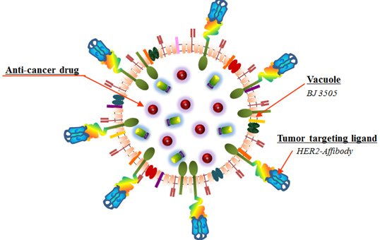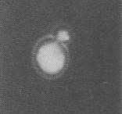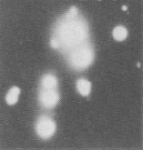

**Normal**

**Vacuoles**

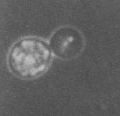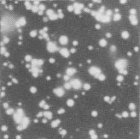

**Fragmented**

**Vacuoles (ΔYPT)**

The EMBO Journal (1995) 14;21 pp.5258-5270

**a**

**b**

Fig.1 a. Conceptual image of AffiHER2VacuoleDrug. HER2-affibody on surface of vacuole acts as tumor targeting ligand, while our drug is loaded inside vacuoles. b. Image of normal and △YPT7 yeast showing fragmented vacuoles. Due to YPT deletion, yeast fusion gets defected. With these fragmented vacuoles we can prepare large number of nano-sized drug vehicles from yeast.

For drugs to be successfully delivered to their target site, delivery vehicles conjugated with targeting antibodies are often used. This way we can unload mass amount of drugs on specific cancer site. There are two delivery vehicle types: synthetic and bio-inspired. Currently many bio-inspired vehicles are actively investigated as they are evolutionally confirmed safe way to deliver drugs to a target.

There are many candidates for drug delivery vehicles; recombinant bacteria, viral vectors, liposomes and so on. But here, we are going to talk about yeast vacuole system. The advantage of yeast vacuole is that it’s from eukaryotic system, so it can minimize self defense mechanisms in other eukaryotes, and such vacuoles can be mass produced from a single yeast.

For this study we have used Doxorubicin loaded in HER2 affibody expressing vacuoles to see its effect in xenograft mouse model. Doxorubicin is an anticancer drug known to have cytotoxic effect via triggering apoptosis pathways, mainly by damaging the DNA. Although it is a prominent anticancer drug, it can also induce apoptosis in other healthy tissues causing toxicity in major organs; like heart, lung, liver, kidney and spleen. So here, we are using yeast vacuole to safely deliver Doxorubicin by targeting HER2 receptor in cancer cells with HER2 affibody.

To produce mass amount of vacuoles from yeast, we have used yeast strain BJ3503-△YPT7. YPT7 gene encodes a GTP-binding protein which regulates tethering and docking actions during membrane fusion. During mitosis, fragmented vacuoles gather to fuse into a large size vacuole. But if YPT7 gene is nullified, highly fragmented vacuoles remain in yeast, and from these yeasts we have gathered vacuoles for drug vehicles.

To induce caner on mouse, we used NIH3T6.7 cells which are HER2 overexpressed fibroblast cells. And for further studies, we have cloned *Pseudomonas aeruginosa* exotoxin A (ToxA). ToxA is one of virulence factor, with known anti-cancer activity. This toxin acts by inhibiting functions of elongation factor-2 (EF2, leading to inhibition of polypeptide synthesis and induction of apoptosis. We were interested in using this toxin to kill cancer cells by specifically delivering it via targeted vacuole system.

**Results**

*Cell uptake of Doxorubicin*

To see effectiveness of our HER2 targeted vacuole compared to non-targeted one, we performed cell uptake assay using NIH3T6.7 cells. With HER2 affibody expressed on its surface, our AffiHER2VacuoleDox is expected to deliver more Doxorubicin to HER2 expressing cancer cells compared to non-targeted one.

Fig.2 shows confocal images of two cell groups each treated with AffiHER2VacuoleDox and VacuoleDox. In 6h image, a clear difference is shown between the two samples. While high concentration of Doxorubicin is present throughout the cytoplasm in AffiHER2VacuoleDox treated cells, there is very low amount of Doxorubicin in VacuoleDox treated samples. Also from the 24h image, we can see delivered Doxorubicin successfully gets inside the nucleus to promote cell apoptosis.

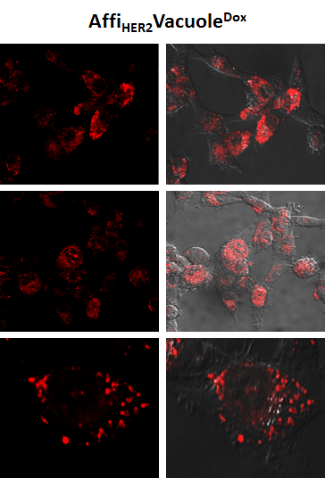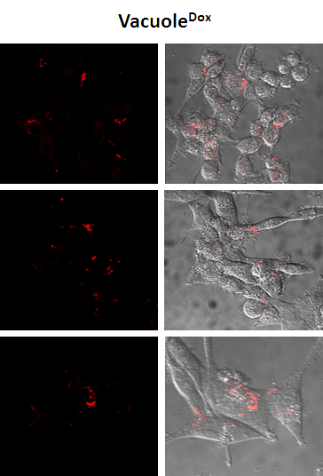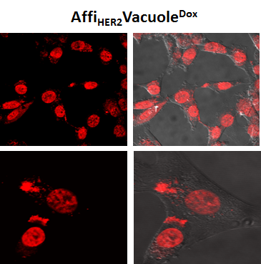

**6 h**

**24 h**

Fig. 2 Cell uptake for AffiHER2VacuoleDox using NIH3T6.7 cells. Each NIH3T6.7 cell groups were treated with AffiHER2VacuoleDox and VacuoleDox. Confocal images were taken at 6h and 24h after the treatment. In 6h samples, high concentration of Doxorubicin from AffiHER2VacuoleDox successfully enters cytoplasm of HER2 expressing NIH3T6.7 cells, while from VacuoleDox there is only small amount of Doxorubicin delivered to the cell. In 24h image, Doxorubicin is successfully transported into the nucleus.

*In vivo tumor targeting study*

NIH3T6.7 xenograft model is used to see effectiveness of AffiHER2VacuoleDox*in vivo*. When the transplanted tumor was grown to a proper size (~100mm3), we injected 1mg/kg dose of FreeDox, AffiHER2VacuoleDox and VacuoleDox intravenously by tail. Samples of tumor tissue were taken at 6h and 12h after injection. Fig.3 shows the confocal image of each tissue samples. Top rows are images taken from the top portion of the tissue and images in bottom rows are taken from the center of the tissue.

Among three treated groups, AffiHER2VacuoleDox treated group shows the highest fluorescence at all tissue section levels. Concentration of Freedoxorubicin rapidly decreases as it gets to the center of tumor section, which means that drugs are not taken up thoroughly. Also from 6h and 12h images, we can see free doxorubicin was cleared rapidly from the sample compared to other treatment groups.

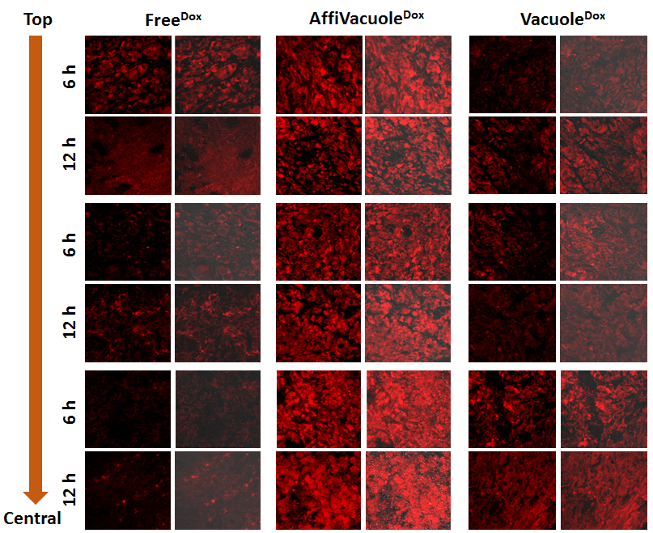

Fig. 3 In vivo tumor targeting study on NIH3T6.7 xenograft model. NIH3T6.7 cells were transplanted on mouse, and each samples were treated with FreeDox, AffiHER2VacuoleDox and VacuoleDox (1mg/kg). Images were taken each at 6h and 12h after the injection. The highest fluorescence is observed in AffiHER2VacuoleDox treated group. Free doxorubicin treated group shows decreasing concentration as it gets deeper into the center of the tissue, and it’s cleared rapidly from the tissue compared to other treatment groups.

*In vivo anti-tumor study*

Mouse NIH3T6.7 xenograft models were regularly treated with doxorubicin to see its effect on tumor growth. 1mg/kg of PBS, FreeDox, Doxil, VacuoleDox, AffiHER2VacuoleDox, and AffiHER2Vacuole were intravenously injected to each mouse groups every other day. And at the day of injection, body weight of mouse was measured to insure they are healthy.

Fig.4.a shows tumor volume measured at each day of injection. As expected, tumor volume was high on PBS and AffiHER2Vacuole injected groups, which contained no doxorubicin. Among the other treatment groups, targeted delivery system showed higher effect on reducing tumor growth. However non-targeted commercial drug Doxil showed antitumor effect as much as targeted AffiHER2VacuoleDox.

Fig.4.b shows tumor tissues taken from mouse at the last day of treatment, and Fig.4.c shows tumor weight of these samples. Fig.4.d shows body weight of mouse taken at each day of injection. There was no significant body weight loss on any treatment groups.

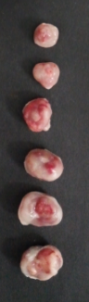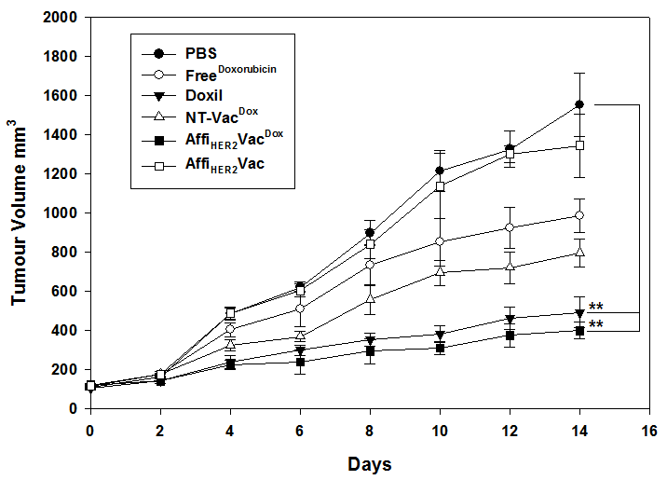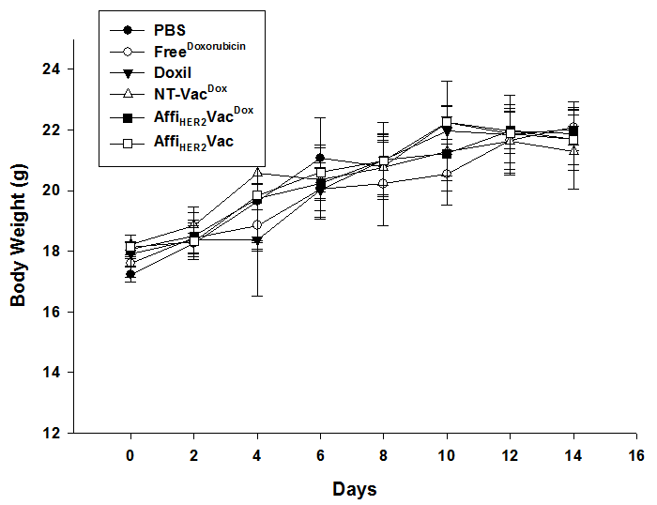

**a**

**b**

**d**

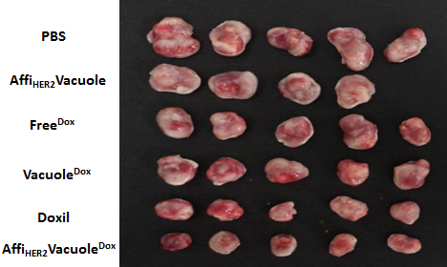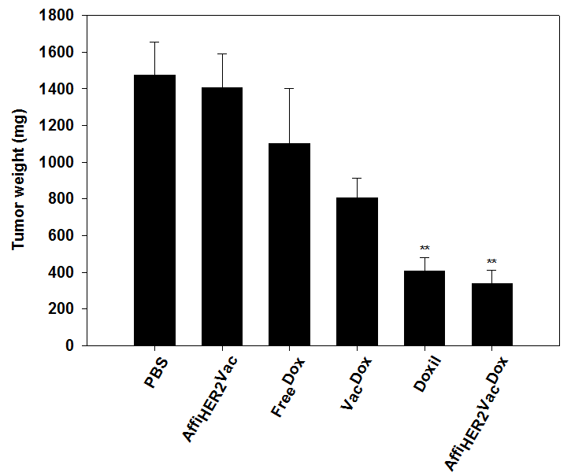

**c**

Fig.4 In vivo anti-tumor study on NIH3T6.7 model. PBS, FreeDox, Doxil, VacuoleDox, AffiHER2VacuoleDox, and AffiHER2Vacuole (1mg/kg) were intravenously injected to each mouse groups every other day. a. shows tumor volume measured at each day of injection. Targeted vacuole system generally shows greater antitumor effect. b. shows tumor tissues taken from mouse at the last day of treatment. c. shows tumor weight of each treatment group taken at last day. d. shows body weight of mouse taken at each day of injection. There was no significant body weight loss on any treatment groups.

*TUNEL assay*

To see apoptotic effect of doxorubicin delivered by AffiHER2Vacuole, we performed TUNEL assay. Nuclei were stained with PI, and nicked DNA due to apoptosis were stained by BrdU-FITC. As in Fig.5.a, large number of cells were stained with BrdU-FITC in AffiHER2VacuoleDox treated group, indicating that doxorubicin delivered by AffiHER2Vacuole successfully acts on target cells to induce apoptosis.

Fig.5.b shows TUNEL assay result of different treatment groups; FreeDOX, VacuoleDox, Doxil, and AffiHER2VacuoleDOX. More green fluorescence is observed in commercial Doxil and targeted AffiHER2VacuoleDOX compared to FreeDOX and non-targeted VacuoleDox, which means Doxorubicin has more readily entered nuclei of cells and triggered apoptosis.

**b**

**a**

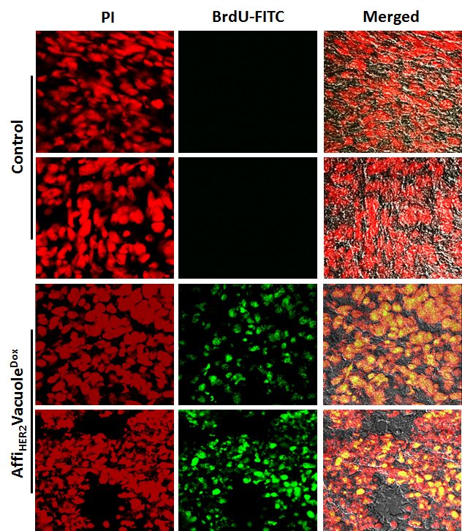

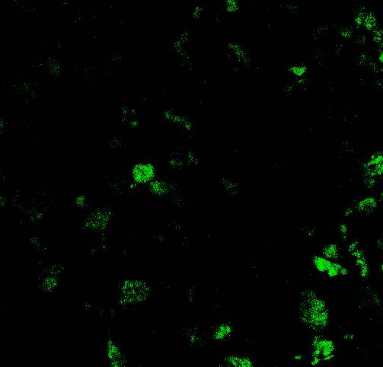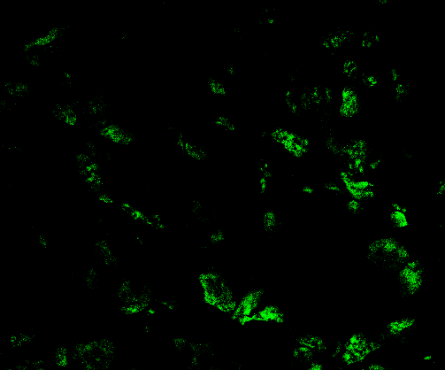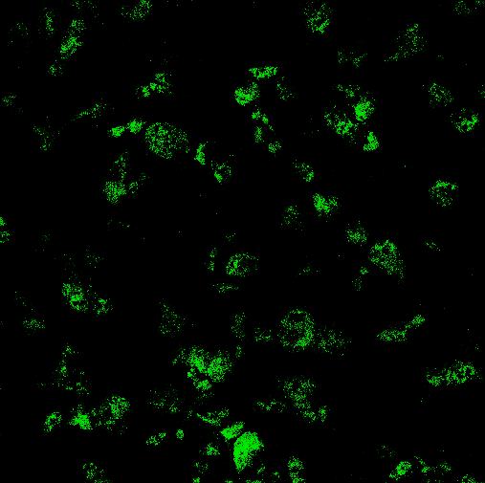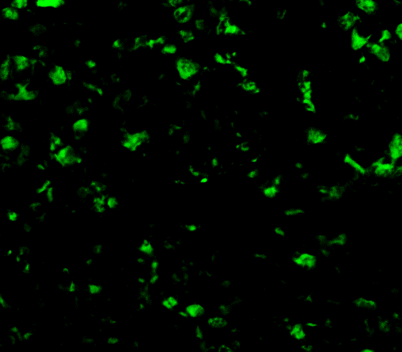

**FreeDOX**

**AffiHER2VacDOX**

**Doxil**

**VacDOX**

Fig.5 TUNEL assay of AffiHER2VacuoleDox. a. Unlike control group, large number of cells were stained with BrdU-FITC in AffiHER2VacuoleDox treated group. It clearly shows that doxorubicin delivered by our AffiHER2Vacuole successfully acts on target cells. b. BrdU-FITC staining image of FreeDOX, VacuoleDox, Doxil, AffiHER2VacuoleDOX treated samples. Fluorescence is high on commercial Doxil and targeted AffiHER2VacuoleDOX compared to FreeDOX and non-targeted VacuoleDox.

*Cloning of ToxA*

Other than doxorubicin, we wanted to load other drugs on AffiHER2Vacuole and see its effect on tumor tissues. So we cloned exotoxin A (ToxA) to load it in our vacuole. Vector (p404GAL1) and insert were restricted with PstI and EcoRI (Fig.6.a). After ligation and transformation, we picked colonies and performed colony PCR to check our ToxA was successfully cloned (Fig.6.b). Then, following clone confirmation by sequencing (Fig.6.c), we sent our toxA to vacuole preparing lab at GIST to express the toxin into AffiHER2Vacuole.

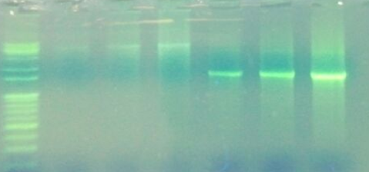

Vector Insert

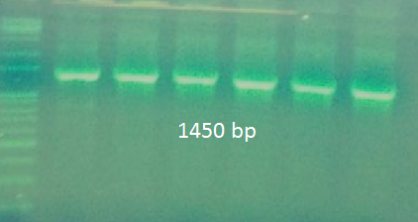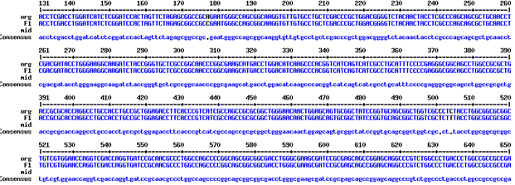

**a**

**b**

**c**

Fig.6 Cloning of Clostridium difficile toxin A (ToxA). ToxA was cloned for further study on our targeted vacuole system. a. Vector (p404GAL1) and insert restricted with PstI and EcoRI. b. Result of colony PCR. c. Clone confirmation by sequencing.

**Discussion**

From the results of our in vivo experiments, targeted vacuoles seems promising to be used as vehicles for drug delivery. It shows higher rate of successful delivery to the site which results in greater drug effect compared to non-targeted delivery system. And by further studying on bio-distribution of loaded drugs, we expecting to see targeted drug delivery system also has lower risk on other healthy organs.

But on some cases, commercial non-targeted drug, Doxil, showed similar anticancer effect as our targeted AffiHER2VacuoleDox. We suspect that such high effect of Doxil is due to multiple modifications on delivery system to bring out highest performance of drug. Given that method of our targeted vacuole delivery system is still rough, performance will be maximized as we modify and tune the delivery system.

**Materials and Methods**

*Yeast strain and cell culture*

YPY7 deficient BJ3505 strain was used for vacuole preparation. HER2 affibody was prepared and introduced to BJ3505 strain to give targeting capability to yeast vacuoles. Vacuoles are then purified according to their size and morphology. For the tumor cell, NIH3T3 mouse fibroblast cells were transfected with HER2, referred to as NIH3T6.7.

*Drug loading on vacuoles*

Doxorubicin hydrochloride was mixed with AffiHER2Vacuoles using magnetic stirrer overnight at ~4oC. Unloaded free drug was removed by ultrafiltration using 100u Millipore membrane. Samples were washed with PS buffer for 6-8 times and concentrated to one ml. The final sample was passed through 0.80 u cellulose acetate filter.

*Cell uptake assay*

NIH3T6.7 cell groups were each treated with AffiHER2VacuoleDOX and VacuoleDOX suspended in MEM media. After washing with PBS, samples were fixed with 4% PFA and monitored by confocal microscope. Images were taken 6h and 24h after the treatment to see doxorubicin release from the vacuole to nucleus.

*In vivo tumor targeting study*

NIH3T6.7 cells were injected in right lumbar side of 6-8 week old female nude mice. When the tumor size reached proper volume, FreeDOX, AffiHER2VacuoleDOX and VacuoleDOX were each injected intravenously via tail vein. After 6h and 12h from injection, tumor tissue were taken out from mice, and red fluorescence from doxorubicin was observed by confocal microscope.

*In vivo antitumor study*

Same NIH3T6.7 injected female nude mice were used as treatment group. When the tumor volume was about 100-120 mm3, PBS, FreeDox, Doxil, Non-targeted VacuoleDox, Targeted AffiHER2VacuoleDox, AffiHER2Vacuole were injected via tail vein every other day. Tumor volume was calculated at day of injection as (length x width2)/2. And weight of mouse was also checked to insure it’s under healthy state. Graphs were drawn using Sigma Plot.

**Reference**

1. Tacar, O; Sriamornsak, P; Dass, CR (2013). "Doxorubicin: an update on anticancer molecular action, toxicity and novel drug delivery systems.". The Journal of Pharmacy and Pharmacology **65** (2): 157–70.

2. Winkler ME; Wilson BJ; Salyers AA; Whitt DD (2010). Bacterial Pathogenesis: A Molecular Approach. Metals Park, Ohio: ASM.

3. Wichmann H; Hengst L; Gallwitz D; (1992). “Endocytosis in yeast: evidence for the involvement of a small GTP-binding protein (Ypt7p)." Cell**71**:1131-1142.

4. Mitri Z, Constantine T, O'Regan R (2012). "The HER2 Receptor in Breast Cancer: Pathophysiology, Clinical Use, and New Advances in Therapy". Chemother Res Pract **2012**: 743193.

5. Armstrong, J. (2010). “Yeast vacuoles: more than a model lysosome.” Trends in Cell biology **20**(10): 580-585.